PostgreSQL Settings

To access the collaboration feature, in True Code we have two database settings.
One of them is PostgreSQL. Please follow below steps to set it up:
Step 1: Install PostgreSQL server on some server on internal network. ( https://www.postgresql.org/)
Step 2: Let the PostgreSQL server run with desired server settings. By default, during installation "postgres" db will be created. It is important to note that, although this DB will show in list of DBs in True Code due to different schema it cannot be used by True Code and can serve only as indication if connection is succesfull.
Step3: the change to pg_hba.conf to allow connection from user machine, in our conf we have only single line added -> host all postgres 192.168.10.0/24 md5
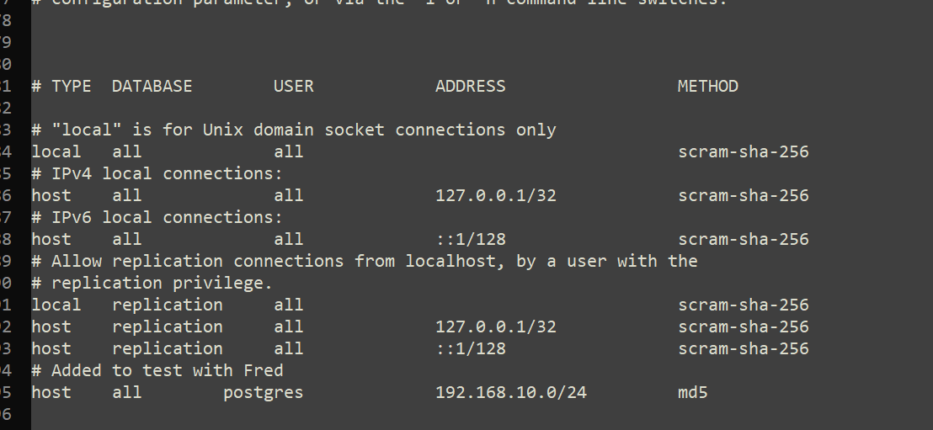
for more info please refer to the link :https://www.postgresql.org/docs/9.4/auth-pg-hba-conf.html
Step4: DB is created by True Code given the name, so it should not be created manually. If default PostgreSQL settings are used, port is set to 5432. Server name- the server name you chose to install in your environment.
Step 5: Establish connection by adding the username/password in the plugin configuration fields where the DB's are populated in the dropdown just below. 